**Lab 22**

**Name :-** Aryan Dilipbhai Langhanoja

**Date :-** 30-10-2023

**Enrollment No :-** 92200133030

**CO1: To write, test, and debug simple Python programs**

**CO2: To implement Python programs with conditional, loops and functions**

**Task 1:- Writing in Files Using Python**

**Python Code:**

import _mysql_connector

import os as o

f = open('92200133030.txt', 'w')

f.write('1) Programming With Python\n')

f.write('2) Computer Organization And Architecture\n')

f.write('3) Introduction To Communication Enginnering\n')

f.write('4) Discrete Mathematics and Graph Theory\n')

f.write('5) Signals and Systems\n')

f.write('6) Data Structures Using C++\n')

f.close()

**Output:**

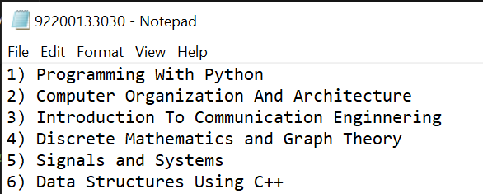

**Task 2:- Appending Text In A Text file in Python**

**Python Code:**

import _mysql_connector

import os as o

f = open('92200133030.txt', 'a')

f.write('7) Stock Market For Beginners\n')

f.close()

**Output:**

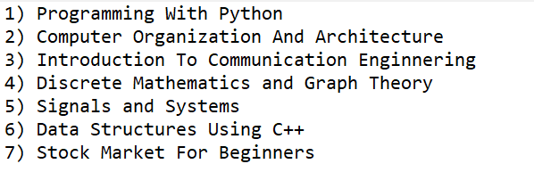

**Task 3:-** **Reading the files using python**

**Python Code:**

import _mysql_connector

import os as o

f = open('92200133030.txt', 'r')

print(f.readline()) # Read First Line

print(f.readlines()) # Read All Next Lines

print(f.read()) # Read Entire File

**Output:**

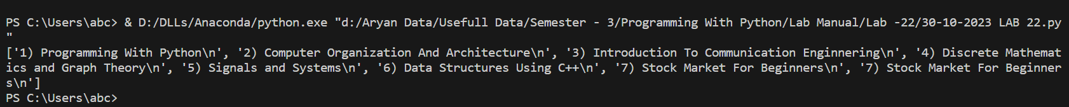

**Task 4:- Exception Handling in File**

**Python Code:**

import _mysql_connector

import os as o

try:

f = open('92200133030.txt', 'r')

print(f.read())

finally:

f.close()

**Output:**

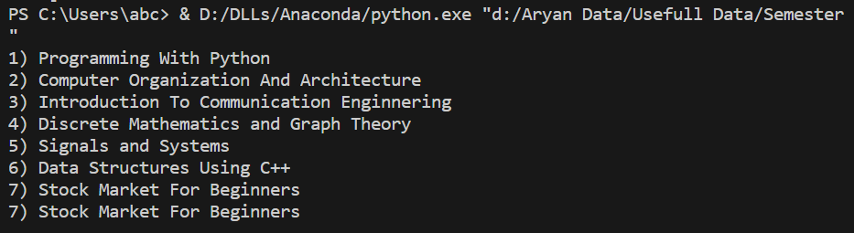

**Task 5:- Processing (With Statement Is Equivalent to the try-finally Statement)**

**Python Code:**

import _mysql_connector

import os as o

with open('92200133030.txt', 'r') as f:

for line in f:

line = line.strip()

print(line)

**Output:**

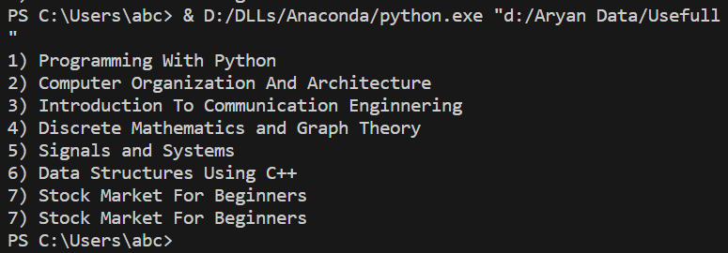

**Task 6:- Deleting File**

**Python Code:**

import _mysql_connector

import os as o

o.remove('92200133030.txt')

**Output:**

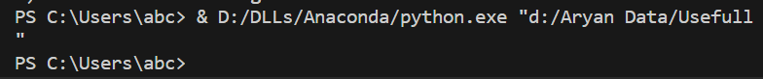

**Post Lab**

**Task 1:- Write a python code for create a binary file and read operations.**

**Python Code:**

import _mysql_connector

import os as o

# Crating Binary File

with open('Binary File.bin', 'wb') as file:

Binary_Data = bytes([13, 12, 54, 32])

file.write(Binary_Data)

# Read Binary File

with open('Binary File.bin', 'rb') as file:

data = file.read()

print(f"Binary Data :- {data}")

**Output:**

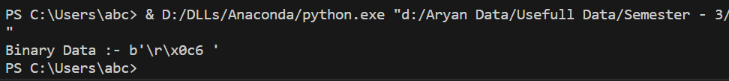

**Task 2:- Write a statement in Python to perform the following operations**

1. **To open a binary file “LOG.DAT” in read mode**
2. **To open a binary file“LOG.DAT” in write mode**

**Write a python code for following functions**

**readable()**

**writable()**

**writelines()**

**Python Code:**

import _mysql_connector

import os as o

try:

with open("LOG.DAT", "wb") as file:

print("File opened in write mode.")

if file.writable():

print("The file is writable.")

else:

print("The file is not writable.")

except PermissionError:

print("Permission denied.")

try:

with open("LOG.DAT", "rb") as file:

print("File opened in read mode.")

if file.readable():

print("The file is readable.")

else:

print("The file is not readable.")

except FileNotFoundError:

print("File not found.")

with open("output.txt", "w") as file:

lines = ["Line 1\n", "Line 2\n", "Line 3\n"]

file.writelines(lines)

**Output:**

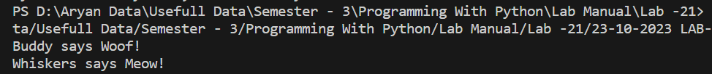

**Task 3:- Write a python code to copy the content of one file into other**

**Python Code:**

import _mysql_connector

import os as o

f = open('92200133030.txt', 'w')

f.write('1) Programming With Python\n')

f.write('2) Computer Organization And Architecture\n')

f.write('3) Introduction To Communication Enginnering\n')

f.write('4) Discrete Mathematics and Graph Theory\n')

f.write('5) Signals and Systems\n')

f.write('6) Data Structures Using C++\n')

f.write('7) Stock Market For Beginners\n')

g = open('92200133030(1).txt', 'w')

data = f.read()

g.write(data)

print(g.read())

f.close()

g.close()

**Output:**

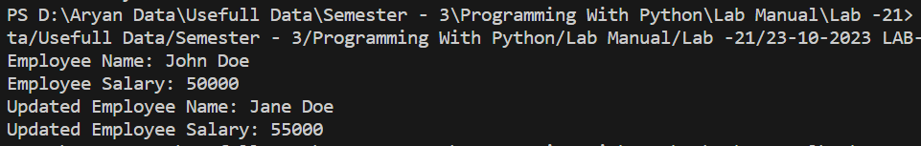

**Task 4:- Write a python code to check whether the particular string is present in file or not.**

**Python Code:**

def is_string_present_in_file(file_path, search_string):

try:

with open(file_path, 'r') as file:

file_contents = file.read()

if search_string in file_contents:

return True

else:

return False

except FileNotFoundError:

print("File not found")

except Exception as e:

print("An error occurred:", str(e))

return False

file_path = '92200133030.txt'

search_string = 'Programming With Python'

if is_string_present_in_file(file_path, search_string):

print(f"The string '{search_string}' is present in the file.")

else:

print(f"The string '{search_string}' is not present in the file.")

**Output:**

